Very Brief Advice – Stop Smoking
- Attar-Zadeh, Darush (NHS North West London ICB - W2U3Z)
  - Treating Tobacco Dependency specialist Clinical Fellow Respiratory Pharmacist IP
  - Email?
- Katie Edwards – LBBD = Tobacco Dependency Advisor 12 week support nicotine replacement
  - Refer: https://services.thejoyapp.com/en/transactions/new?listing_id=15470
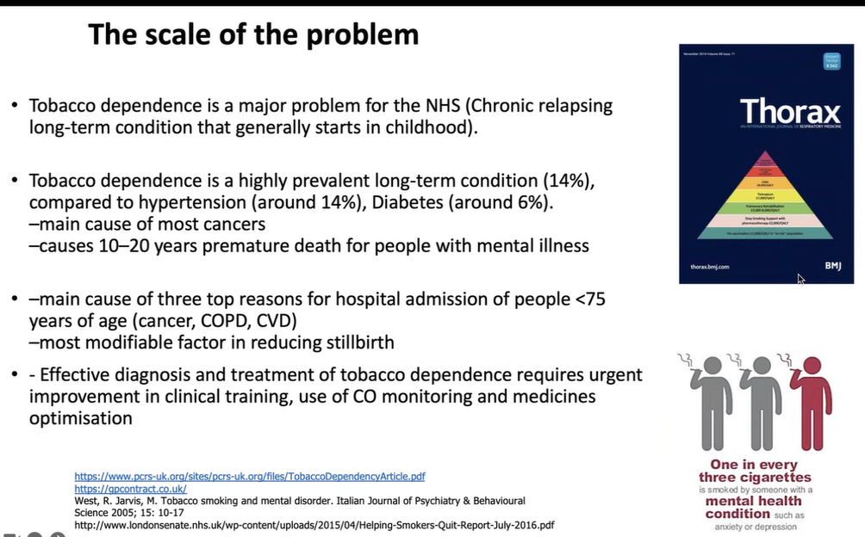
- 1/3 smokers – have a mental health disorder and a premature death
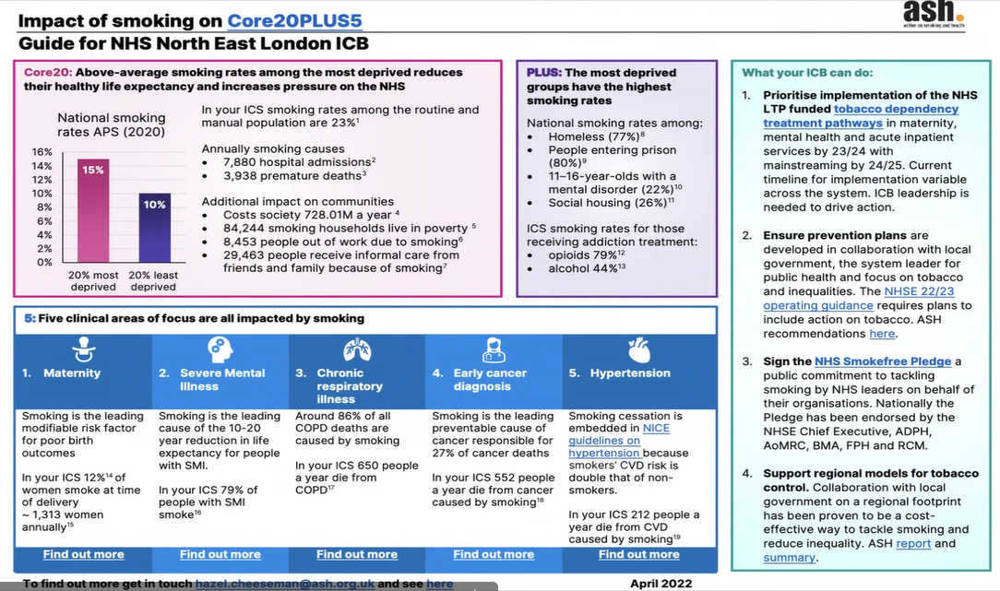
- Short half life of nicotine requires smokers to regularly smoke to main levels
- Reinforcing desired effects of nicotine with each cigarette soon becomes addictive
- 7 seconds to travel the brain
- Nicotine is as addictive as cocaine and heroin
- Withdrawal system
- Dopamine = happiness
- How many cigarettes do you typically smoke per day?
- On the days that you smoke, how soon after you wake up do you have your first cigarette?
- Patch (two gold rectangles) given over time of 25 grams, but on its own it is not good enough
  - Non hairy part of the body to stick it on and change the place each time
  - If sleep is disturbed, use
    - Avoid tattoos, creams, sweat
      - Causes skin irritation and it subsides with time
        - Use for 8 weeks and with NHS for 12 weeks
          - For some people, it is free
- Spray and Gum/Inhaler/Tabler are faster, but still slow moving
  - Inhalator (no cloud coming out) – hand to mouth device
    - Two lines to match to pull apart and place the cartridge inside and twist it
      - It does not get absorbed in the lungs
        - Avoid acidic drinks or it will get absorbed
  - Vapes (should not use) – MHRA limits to 2ml
  - Mouth spray – thumb to get mist out of it and spray inside the cheek (not to swallow. Can use up to 6 per day
  - Gum – chew it for a few moments and then rest it between the gum and check for absorption.
  - Varenicline (Champix) – tablet medication
    - Local support
    - Digital support
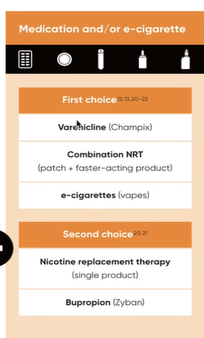
- October
- Nicotine support – 8 weeks
  - Free of charge
  - Vapes (Nicorate or Nicorine)
  - Spray – 4mg
  - Liquid
  - Patches – 21mg to 25mg
  - Oral
    - From 0.1ml decrease to 0.6ml
- Behaviour support – 4 weeks
- GP referrals are slow
- Weekly check ins and then it slows down
- Establish and record smoking status
  - “Do you smoke?/Are you still smoking?”
- Advice how to stop
  - “The best way to stop is with support and treatment”
- Offer support and treatment
  - “When you are ready just make an appointment to see … who can really help you stop!”
- Advertise resources available
- Extra training – https://elearning.ncsct.co.uk/vba-stage_1
- Carbon monoxide (poisonous, intoxicated gas that decreases oxygen to heart and lungs) machine
  - Plastic is inserted
  - Home button
    - Smoking
    - Pregnancy
    - Environmental
  - Count 15 to 0 seconds
  - After the seconds are over, breathe in
